How to Access the website
Follow the instructions below using the sample link provided: https://35.198.233.36:8090/api/smartrpd/case/get/797
Step 1: Paste the Link in the Search Bar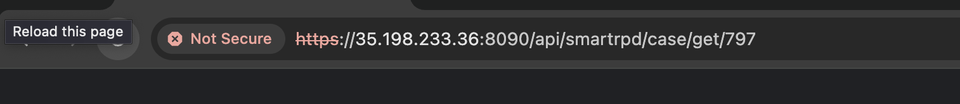

Step 2: Click on "Advance"
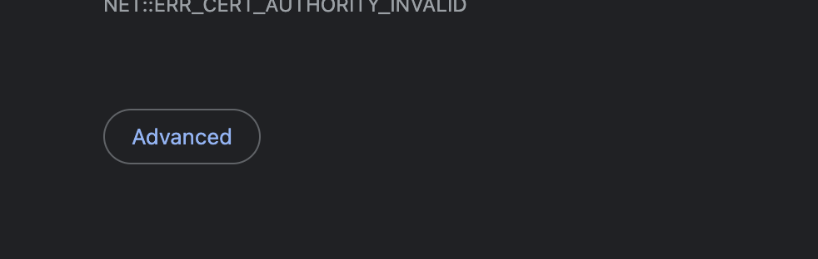

Step 3: Click on the Blue Link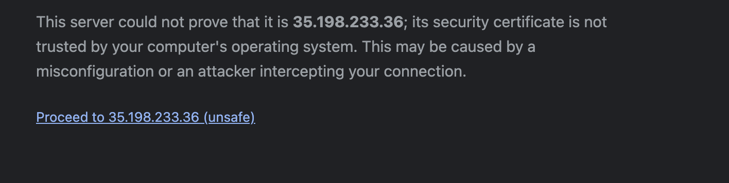

Step 4: Paste the Link for the Web-RPD in search bar
Link: https://wyl-asg.github.io/finale/?id=OAJBLhkNOQoOdFADDmMBGQ

